**The British School of Costa Rica**

**Senior 7 Fieldwork: February 2011**

**Quepos: Costa Rica**

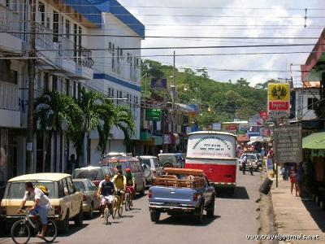

**Information Pack**

**Name:____________________**

j0235319**Geographical Studies in Urban Morphology**

At the end of this investigation you should fully understand and be able to demonstrate your understanding of the following:

**Site:** the physical characteristics of the land where a settlement is located.

**Situation:** the location of a place relative to its surroundings.

**Functions:** the main activities in an area. This can change over time and relates to its social and economic development.

**Core & frame of CBD:** Areas of different land uses and functions within the CBD, as shown in the diagram opposite.

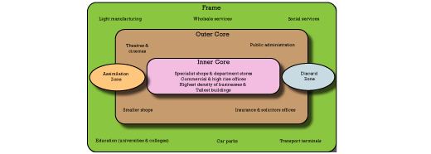

**Delimiting of CBD:** Work out how far the CBD extends with in an urban area.

**Peak Land Value Intersection (PLVI):** The most economically valuable site within the CBD.

**Anomaly:** Exception to the rule, data that does not fit the pattern.

**Negative correlations:** A correlation (relationship) where an increase in the value of one variable is matched by a decrease in the value of another variable.

**Positive Correlation**: A correlation (relationship) where an increase in one variable is matched by an increase in the value of the other.

j0205462**Mapping functions & building height:**

**FUNCTIONS**

When constructing maps of urban land use it is a good idea to use a code. This allows you to quickly note the main types of land use. Then you can use colour or a shading scheme for your final map.

This classification is called the RICE POTS – the name comes from the general code letters. There are 2 codes for each land use. The first is a general code letter, the second describes it in more detail.

**R residential**

F flat

T terraced house

S semi detached house

B bungalow

D detached house

**I industrial**

L light manufacturing

H heavy manufacturing

C chemical works

B building works

E extraction (mined)

**C commercial**

F food shop

P personal services

D department stores

Y furniture and carpets

V vacant or under construction

G garage

M market

S specialist shop

O office

**E entertainment**

H hotel

S sports centre

T theatre and cinema

B bar

R restaurant and cafe/soda

**P public buildings**

E education & libraries

H hospital

C church

P police

W welfare

**O open space**

F farmland

P park

C cemetery

U unused land

D derelict building

S sports field

**T transport**

B bus station

T taxi

C car park

S sea port

**S services**

F financial

B business

M medical

H housing (real estate)

***\* Use X as a second letter for activities you are unsure about.***

On the blank base map proved show the shape of each building then write in its function, using the code on page 3.

**BUILDING HEIGHTS**

Next to each letter showing land use record the number of floors (an attic is counted as 1 floor).

**PE**

**2**

**CF**

**1**

***Example:***

**Street Map of Quepos**

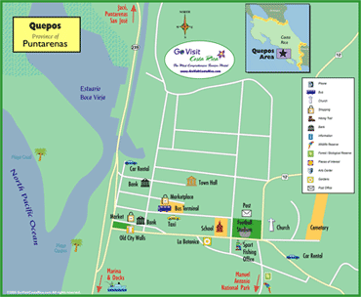

Environmental Quality Assessment

Take a look around each of the sites you have picked, noting the following environmental factors:

|  |  |  |
| --- | --- | --- |
| http://www.starfish.govt.nz/shared-graphics-for-download/yucky-beach.gif | http://www.londonstimes.us/toons/cartoons/johann_skunk.gif | http://www.starfish.govt.nz/shared-graphics-small/resource-conflict-sml.gif |
| Litter & Pollution | Vandalism | Overcrowding |
| scream |  | padlock |
| View & Scenery | Noise | Safety |

Now complete the table below, awarding a score for each factor. For instance, if there is a lot of litter at Site 1, it would score -2, but if there was none, it would score +2.

|  |  |  |  |  |  |
| --- | --- | --- | --- | --- | --- |
|  | Site 1 | Site 2 | Site 3 | Site 4 | Site 5 |
| Description of site |  |  |  |  |  |
| Litter |  |  |  |  |  |
| Vandalism |  |  |  |  |  |
| Congestion& crowding |  |  |  |  |  |
| Natural Surroundings |  |  |  |  |  |
| View |  |  |  |  |  |
| TOTAL SCORE |  |  |  |  |  |

As you complete the Environmental Quality Assessment, consider the circumstances which may alter a person’s perception of each site, for instance; season, time of day, weather, their own personal background and preferences.

**Vehicle and Pedestrian Count: DATA SHEETS**

For this task you must tally the number of people and the number of vehicles that pass a certain spot over a period of 5 minutes, using the tables below.

Choose at least 10 different locations around Quepos. Be sure to mark these locations on a blank base map (remember to give this map a title)

|  |  |  |
| --- | --- | --- |
| **Site 1:** Location and Time: | | |
| **Type of vehicle** | Tally | Total |
| Car |  |  |
| Motorbike |  |  |
| Bus |  |  |
| Truck |  |  |
| Bicycle |  |  |
| Van or small truck |  |  |

|  |  |  |
| --- | --- | --- |
| Location and Time: | | |
|  | Tally | Total |
| **Pedestrians** |  |  |

|  |  |  |
| --- | --- | --- |
| **Site 2:** Location and Time: | | |
| **Type of vehicle** | Tally | Total |
| Car |  |  |
| Motorbike |  |  |
| Bus |  |  |
| Truck |  |  |
| Bicycle |  |  |
| Van or small truck |  |  |

|  |  |  |
| --- | --- | --- |
| Location and Time: | | |
|  | Tally | Total |
| **Pedestrians** |  |  |

|  |  |  |
| --- | --- | --- |
| **Site 3**: Location and Time: | | |
| Type of vehicle | Tally | Total |
| Car |  |  |
| Motorbike |  |  |
| Bus |  |  |
| Truck |  |  |
| Bicycle |  |  |
| Van or small truck |  |  |

|  |  |  |
| --- | --- | --- |
| Location and Time: | | |
|  | Tally | Total |
| Pedestrians |  |  |

|  |  |  |
| --- | --- | --- |
| **Site 4:** Location and Time: | | |
| Type of vehicle | Tally | Total |
| Car |  |  |
| Motorbike |  |  |
| Bus |  |  |
| Truck |  |  |
| Bicycle |  |  |
| Van or small truck |  |  |

|  |  |  |
| --- | --- | --- |
| Location and Time: | | |
|  | Tally | Total |
| Pedestrians |  |  |

|  |  |  |
| --- | --- | --- |
| Site 5: Location and Time: | | |
| Type of vehicle | Tally | Total |
| Car |  |  |
| Motorbike |  |  |
| Bus |  |  |
| Truck |  |  |
| Bicycle |  |  |
| Van or small truck |  |  |

|  |  |  |
| --- | --- | --- |
| Location and Time: | | |
|  | Tally | Total |
| Pedestrians |  |  |

|  |  |  |
| --- | --- | --- |
| **Site 6**: Location and Time: | | |
| Type of vehicle | Tally | Total |
| Car |  |  |
| Motorbike |  |  |
| Bus |  |  |
| Truck |  |  |
| Bicycle |  |  |
| Van or small truck |  |  |

|  |  |  |
| --- | --- | --- |
| Location and Time: | | |
|  | Tally | Total |
| Pedestrians |  |  |

|  |  |  |
| --- | --- | --- |
| **Site 7**: Location and Time: | | |
| Type of vehicle | Tally | Total |
| Car |  |  |
| Motorbike |  |  |
| Bus |  |  |
| Truck |  |  |
| Bicycle |  |  |
| Van or small truck |  |  |

|  |  |  |
| --- | --- | --- |
| Location and Time: | | |
|  | Tally | Total |
| Pedestrians |  |  |

|  |  |  |
| --- | --- | --- |
| **Site 8:** Location and Time: | | |
| Type of vehicle | Tally | Total |
| Car |  |  |
| Motorbike |  |  |
| Bus |  |  |
| Truck |  |  |
| Bicycle |  |  |
| Van or small truck |  |  |

|  |  |  |
| --- | --- | --- |
| Location and Time: | | |
|  | Tally | Total |
| Pedestrians |  |  |

|  |  |  |
| --- | --- | --- |
| **Site 9**: Location and Time: | | |
| Type of vehicle | Tally | Total |
| Car |  |  |
| Motorbike |  |  |
| Bus |  |  |
| Truck |  |  |
| Bicycle |  |  |
| Van or small truck |  |  |

|  |  |  |
| --- | --- | --- |
| Location and Time: | | |
|  | Tally | Total |
| Pedestrians |  |  |

|  |  |  |
| --- | --- | --- |
| **Site 10:** Location and Time: | | |
| Type of vehicle | Tally | Total |
| Car |  |  |
| Motorbike |  |  |
| Bus |  |  |
| Truck |  |  |
| Bicycle |  |  |
| Van or small truck |  |  |

|  |  |  |
| --- | --- | --- |
| Location and Time: | | |
|  | Tally | Total |
| Pedestrians |  |  |

|  |  |  |
| --- | --- | --- |
| **Site 11**: Location and Time: | | |
| Type of vehicle | Tally | Total |
| Car |  |  |
| Motorbike |  |  |
| Bus |  |  |
| Truck |  |  |
| Bicycle |  |  |
| Van or small truck |  |  |

|  |  |  |
| --- | --- | --- |
| Location and Time: | | |
|  | Tally | Total |
| Pedestrians |  |  |